Short Essay 1: The Im/possibility of Knowledge

Due Monday, October 11th 2021

We have now read and discussed a number of texts in epistemology, the study of knowledge. We’ve thought about truth, lies, and bullshit; what it means to know and whether knowledge is even possible; and how trusting relationships and the social world can affect knowledge or ignorance. Now, you’re asked to discuss one view on the possibility, or impossibility, of knowledge.

General Requirements
Deadline: Midnight EST on the date above
Format: Word document only. If using Google Docs or Pages, download/export as Word:
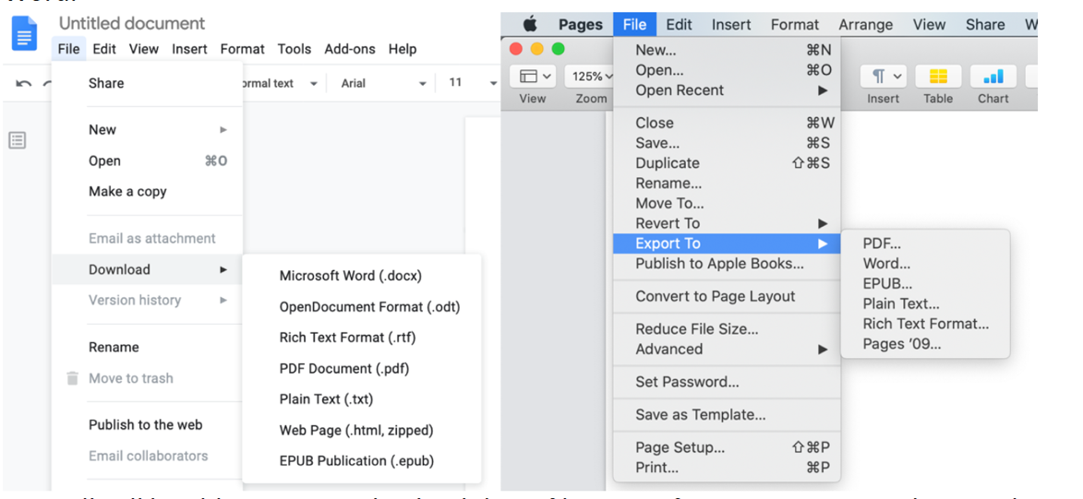

You will still be able to save and upload these files even if your computer can’t open them.
Word count/page limit: Please limit your papers to 2 pages double-spaced maximum. There is no minimum.

Late assignment policy: I accept late papers, but they will lose points for lateness UNLESS you have been granted extra time (see below for details)
- If an assignment is late, you will lose percentage points:
  - 5% for any submission past the hard deadline,
  - 5% for each 24 hours late after that.
- If you submit the wrong file, a corrupted file, or a file in the wrong format:
  - You will lose points for lateness until the error is corrected.
  - I will not check this for you, it is your responsibility to ensure the proper file is uploaded. (I suggest you try downloading it from Blackboard to make sure.)
- I will grant requests for extra time if you need reasonable accommodations due to a disability. Please get in touch with me if this is you.
- I will consider requests for extra time for other reasons, but only if you contact me about it no later than 72 hours before the deadline (i.e., by midnight on Friday, October 8th).

Academic honesty: You are responsible for knowing and following both Brooklyn College’s Academic Integrity Policy and the guidelines in the Referencing and Plagiarism handout I discussed at the beginning of the semester. To find it again, navigate to the class website drop-down menu “Assignments & Grading.” Click “Important Resources”. Download the file named “Kellers-Referencing-and-Plagiarism.”

Directions
Your job in this paper is to thoroughly explain one author’s position on knowledge, or a problem surrounding knowledge. The trick is that you must do so in your own words. In preparation, you should do the following:

- Pick one article from Unit 1 that you feel like you really understood or liked.
- Decide what the author’s main point is in the paper. This is something you should be able to state in about one sentence.
- Figure out how the author got there. What was their argument for their main point? How do the pieces of their argument fit together so that they lead to the main point?
- Figure out how the author supports the pieces of their argument. What evidence (like examples) do they give? How does that piece of evidence support that piece of the argument?

Once you can do (2) – (4) in your own words, you’re ready to write the paper. Structure it as follows:

Introduction. Tell the reader (1) which article your paper is about, (2) who wrote the article and when, (3) what the author of the article’s main point was, and (4) that you will be explaining their argument for that point. That’s it. Do not include a “hook,” catchy first sentence, etc. for example:
In this paper, I will be discussing Book 7 of the Republic by Plato (360BCE, tr. Jowett). Plato’s main point is that _________. I will explain his argument for this point.
You can literally use that text exactly as it is.

Description. Each description paragraph describes one step in the author’ argument, in your own words. Any quotes must be ten words or fewer and if you use a quote, your explanation of it must be at least twice as long as the quote itself. These paragraphs tell the reader (1) what point the author is making in this step of the argument, and (2) how they justify that step. I highly recommend that you use concrete examples, and that you thoroughly explain those examples.

Conclusion. In a few sentences, restate the main point and explain how each step of the argument you discussed above leads to the author’s main point.

Short Essay 1: Grading Rubric

Due Monday, October 11th 2021

Each of your three papers are worth 10% of your final grade (30% cumulatively).

Your first essay (this one) will be graded Pass/Fail. I will give you feedback on the writing and content, and tell you what your grade would have been, had I used the rubric below. You will write your next to essays considering my feedback and they will be graded according to rubrics which are similar to the one below.

Your feedback on this paper will be awarded points on the following criteria (there are 40 available points). No matter how you do on this paper, you will pass as long as you do not plagiarize. Still, it is worth working from the below rubric/checklist, because your next two papers will not be Pass/Fail.
Introduction, 5 points:
☐ 1 point for correctly and completely stating the author, year, and title of the text your paper is about.
☐ 1 point for correctly stating the author’s main point in that article.
☐ 1 point for stating that you will be explaining their argument in your paper.
☐ 1 point for not including flowery introductory language (ex., “Since the dawn of time…”)
Description Paragraphs, 25 points total:
☐ 10 points for clearly and correctly stating what happens in each step of the argument.
Maximum of 5 points if quote policy is not followed.
☐ 10 points for clearly and correctly explaining how the author justifies each step.
Maximum of 5 points if quote policy is not followed.
☐ 5 points for including correct, well-explained examples when appropriate.
Maximum of 2 points if quote policy is not followed.
Conclusion, 5 points:
☐ 1 point for correctly and clearly re-stating the author’s main point.
☐ 1 point if you re-state the main point without copying from your introduction.
☐ 3 points for clearly and correctly explaining how each step leads to the main point.
Mechanics and Structure, 5 points:
☐ 1 point for appropriate use of separate paragaphs.
☐ 2 points for using the correct style in referring to or citing the author (including bibliography)
Maximum of 1 point for attempting to cite but doing it wrong.
☐ 2 points for using proper grammar, spelling, and punctuation throughout.

You will receive a 0 if you plagiarize at all, intentionally or unintentionally.

